University of Regina

Then and Next: An Analysis in Evolution on Painting and Fantasy Literature

Noe Morin

200373818

CTCH499

April 8, 2021

Art is in a constant state of flux. It not only changes through time, but also through the eyes of each person looking at it. As a fluid set of media, it is also prone to bearing humanity’s bias and perception towards the things in our present world. Massive changes in our society are reflected in art, via the interpretation of the artist and then is altered even further by the understanding of its audience. A post-pandemic setting serves as a prime example of this change. Humanity has, of course, experienced pandemics before, each of them varying in severity. Here in the aftermath of a pandemic, art changes to the themes and interests of the artists and art-seekers, thus changing art from what it was before the pandemic swept across history. It is after one these pandemics where this paper will focus, with an attempt to look forward passed the COVID-19 pandemic. The goal is to identify change in art, specifically in the fields of painting and fantasy literature, in order to predict where art might go in the near future. The major pandemic that this essay will focus on via the method of a controlled case study is that of the Black Death, which ranged from the mid-14th century to the early years of the 15th. This particular choice was made for reasons that will mostly be elaborated on later, but one stands above the rest: The drastic change in artistic tone and theme coming out of painting and literature in the years following the pandemic’s outbreaks. These particular points of focus pose many questions over the future of art and what it might look like, especially with society’s increased reliance and use of technology. In studying this ‘age of digitization’, we hold an opportunity to judge what we might lose come a full-bore technological future, or what we might gain if the boundaries of technology and nature begin to transcend each other.

In order for us to fully be able to understand the changes art goes through, we must first define what art means to us as individuals and as a group society. The subjectivity of art is always brought up when talking about all of its varieties. The personal human perception and sense of individuality is encouraged when looking at art, as it can touch all people in differing ways depending on experience. Our own points of view give us the sense of individuality from others, even from those whom we share the same name. Painting and fantasy literature are two such things where individual interpretation is important, and is what gives people the opportunity to pick and choose favourite styles, artists, and authors. What is interesting about art is how it is subject to the changes around us, how it reflects those changes, and how audiences react and interact with changes in the pieces.

**The Black Death:** Art in the Face of Catastrophe

In 1347, Europe was to be struck by one of the worst natural disasters to ever happen to humankind. In the late 14th and early 15th century, trade routes had begun developing all over Europe and Asia, stretching from one end of the continent to the other and connecting different cultures along a web of routes and paths. Many of these routes were also traced out along the sea, flowing from India up to ports in Sicily, Italy, and others. As necessary as the need for trade was, it also marked one of the most important things for the spread of disease outside of a contained population: passage and transportation with perfect conditions for the main carrier, Yersinia Pestis, and its survival.[1] This spread would mark the third pandemic in Europe and Asia. While the origin point of the plague in Europe is still debated to this day, many sources and academics support the theory that the infected fleas found burrows in stores of grain and cloth on board these trade ships from the sprawling Mongol Empire in Asia.[2] Upon arrival with these ships, along with a slower rate of transmission over land, the disease spread far and wide. Much of Europe was affected within the year, and the 14th century systems supporting society were hit hard.

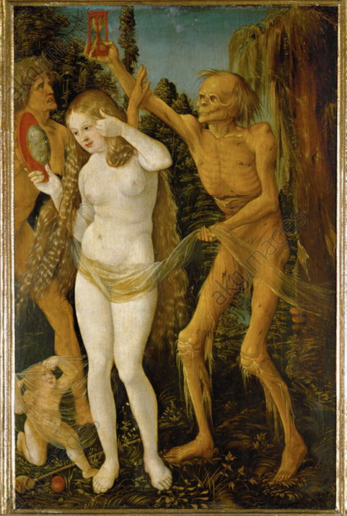

Fig. 1. Hans Baldung Grien, “Three Ages of Woman and the Death” 1510. [https://www.akg-images.com/archive/The-Three-Ages-of-Woman-and- Death-2UMDHU02266.html](https://www.akg-images.com/archive/The-Three-Ages-of-Woman-and-%20%20%20%20%20Death-2UMDHU02266.html)

With the plague recurrences all throughout the latter half of the 14th century, an attitude of collective pessimism began to grow onto people’s outlook on life. They had been surrounded by death for so long, and it had taken a toll on everyone’s psyche. It almost seems as if it was fashionable to be pessimistic, as being constantly aware of its possibility became a main religious focus in the aftermath of the Black Death pandemic.[3] There rose with this pessimism a concurrent theme in the arts and the limited amount of literature: the topics of death and grief. The painting above is the “Three Ages of Woman and the Death (1510)” from Hans Baldung Grien. There is much detail here, from the draining hourglass being held over the woman’s head to the mirror she holds in her hand, and the detail implies much, tying heavily into the themes of death and passing time during the presence of the Black Death. The painting holds an eerie stillness to it, as if the older woman in the background is trying to hold Death from the younger woman, but Death is in no way concerned and seems to wait, patiently gazing at the hourglass filling above.[4]

Many paintings here focused on the sins of man and the weight it had on religious figures like Jesus Christ and God. It is interesting seeing the depictions and descriptions of some of these pieces, since the people of the 13th and 14th century did not blame God for sending the Black Death, rather they pinned it on themselves and the sins *they* committed. One such example of this is Peter Rubens painting called “The Flagellation of Christ” (1617). This painting depicts Christ being whipped by three or four other men that seem to be angry for something. Jost mentions that he seems to glow in comparison with the others depicted in the painting, and that he provides a stark contrast to the darker background.[5] This painting has real significance when considered with the flagellant movements and groups in the late 14th century. The flagellant groups were people who whipped themselves over their own shoulders, and sometimes by others entirely, as a way to reconcile for sins they committed. They did this in an effort to save themselves from the fate of the plague, and it was one of the many religion-driven movements in the 14th century and was not without its controversies.

The symbolism behind this piece in relation to the flagellant movement is incredibly important and remarkable. It reflects the 14th century ideology of the plague being sent by god unto humankind, but even he suffered as it remained throughout the years. This painting manifests those feelings, instead depicting Christ suffering for humanity’s supposed misdeeds, and highlights the compassion the people had for their religious figures and how they wanted to depict them in religious writing, prayer, and painting.

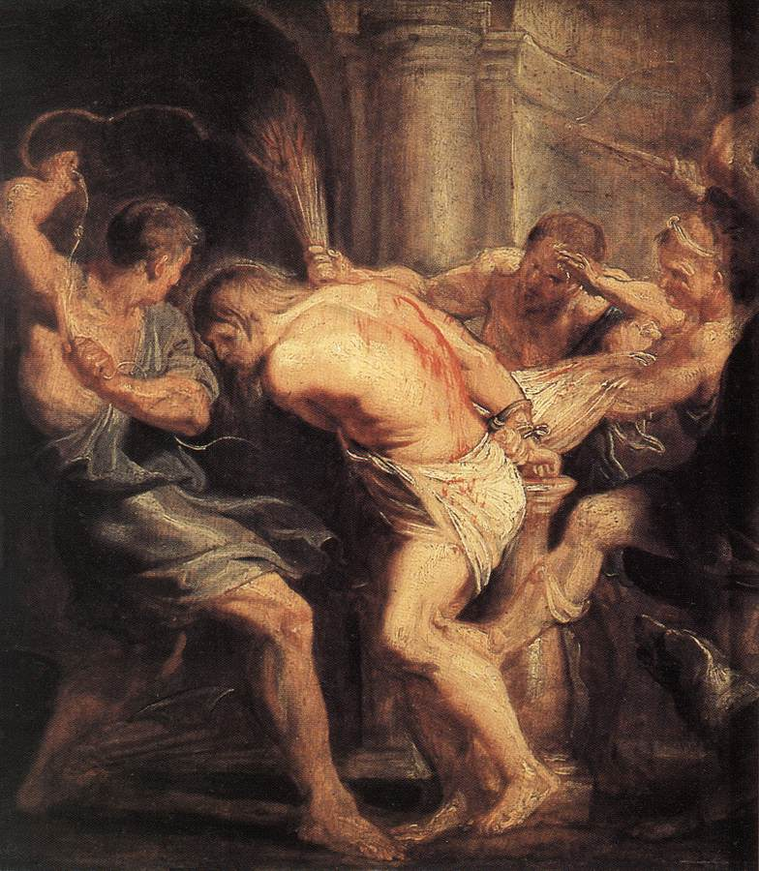

Fig. 2. Peter Rubens, “The Flagellation of Christ” 1617. <https://commons.wikimedia.org/wiki/File:Peter_Paul_Rubens_-_The_Flagellation_of_Christ_-_WGA20432.jpg>

Symbolism of saints and deities had evolved into something that offered reassurance when the people were surrounded with the mass trauma of the Black Death.[6] This also ties into how sin was perceived during the mid-14th century. Europe needed something that they could look to in an effort to hope for something better, rather than focus on what was going on around them.

As for literature, much if the wide range of writers at the time were also attempting to captivate the struggles of the Black Death.[7] Themes of depression, frustration, and anguish in the plague’s wake are frequent among poems, and example being Petrarch’s Sonnet 134, translated by Sir Thomas Wyatt, that Jost mentions:

I find no peace and all my war is done,

I fear and hope, I burn and freeze like ice;

I fly above the wind yet can I not arise;

And naught I have, and all the world I season [sized upon]

That looseth nor locketh holdeth me in prison

And holdeth me not, yet can I ‘ scape no wise,

Nor letteth me live nor die at my device,

And yet of death it giveth none occasion.

Without eyen I see and without tongue I plain [complain];

I desire to perish, and yet I ask health;

I love another, and thus I hate myself;

I feed me in sorrow and laugh in all my pain;

Likewise displeaseth me both death and life;

And my delight is causer of this strife.

Death in the Middle Ages and Early Modern Times : The Material and Spiritual Conditions of the Culture of Death, edited by Albrecht Classen, De Gruyter, Inc., 2016. ProQuest Ebook Central, <http://ebookcentral.proquest.com/lib/uregina/detail.action?docID=4508526>.

It is here where the idea of an ‘escape’ sprung up. Since everyone was already melancholic and feeling mostly the same feelings of grief and despair, many sought a way to escape all of the negativity and pessimism of their age. A particularly famous author to focus on here is Geoffrey Chaucer, the author of the *Canterbury Tales*.[8] As an author, Chaucer had so many writing ‘tools’ at his disposal. Being a writer at the close of the middle ages and during the Black Death, he was able to take advantage of both of these things, romanticizing the Medieval Ages and at the same time offering the escape from reality people were so keen for in their gloomy and depressed world. Alongside his *Canterbury Tales,* Chaucer also wrote *Sir Gawain and the Green Knight* and *La Morte d’Arthur*.[9] Although there were some fantasy writings occurring during the Black Death, much of the writing was religious as the church held a lot of influence. The fantasy literature was also charged with some of the saintly characteristics of the church as well, giving its heroes a much more didactic and heroic journey.[10] Literature was very much constructed around the elevation of sacred values and acts, and these examples of fantasy literature are undoubtedly products of that way of thinking. This charging of values in these fantasy stories creates a degree of imagery through mental pictures and created myths which help people further connect with their beliefs.[11]

**The Turning Gears**: A Tech-Powered Society

Technology’s role in the present day is a pivotal and vital element of modern culture. As a society and world that is increasingly framed and constructed around new technological advances and changes, existence and interactivity with society becomes the ‘technological condition.’[12] Technology functions increasingly like a barrier-hopper; one which hallows connection to a multitude of other people, digitized hobbies, apps, and ease of accessibility. Accessibility and technology are two things that are very tightly knit, especially with the growth of the internet’s complexity. Digitizing and uploading things up onto Instagram, Twitter, and Facebook are normal platforms for the dissemination of media and advertising. As platforms that have accessible accounts and systems, it broadens the horizon of views and interest for many artists. Online databases have always existed in the forms of storage spaces, profiles, portfolios, and backups, but they now are increasingly *visualized.* What I mean by this is that the data store online, whether it be a scan of a painting, or a scan of words on a scrap of paper, is that it is all code at one point or another and then visualized in a way that we can understand it as a piece of art other than something wholly digital. The digital sphere for sharing and displaying art works very much like an ‘interspace’ where “biology and virtuality blend together into a coercive ‘living’ art.”[13] Elwell states that our world is further and further being reduced to code, which is allowing us to learn more about the world in ways we can technologically understand.[14] There are differences between the digital and analog sides of our world and of art. The digital sphere functions as a space for snapshots and mimicry of what was made in the real. Turning a physically painted image into code via a digital photograph, and then further altering the code by having it placed and edited onto a webpage or profile morphs the physical nature of the piece between analog and digital, and yet it can retain meaning and purpose rather than losing it over the translations of its physical (or lack-thereof) state.

The modern-day gallery served as a place for people to experience a piece of art in the same space as themselves. This immediacy can translate different kinds of messages than those we would see in a picture of art, and in painting, that is especially true for detail, scale, and true colour. A gallery is also a place to experience art with other people. While it is true that ‘digital tours’ are possible to an extent, it remains entirely in its own category of display.

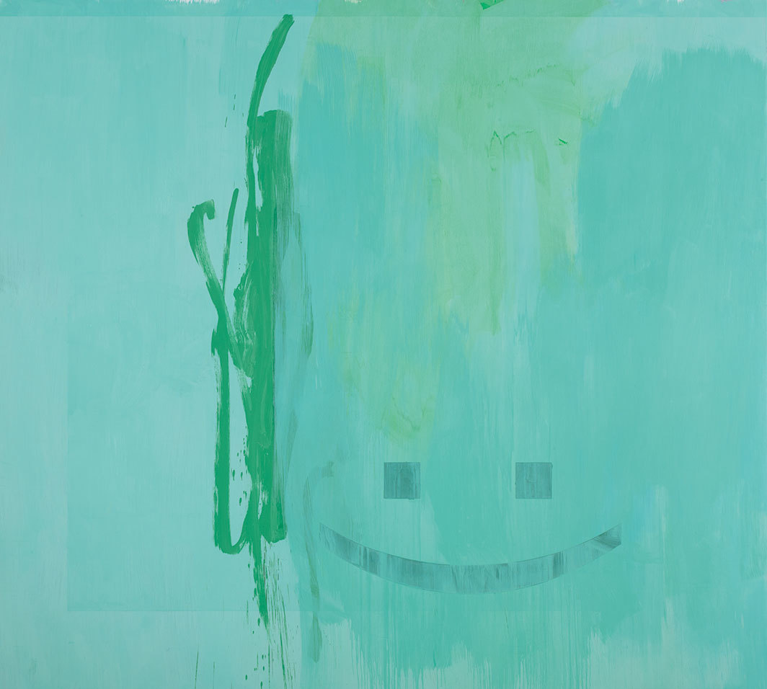

Fig. 3. Jacqueline Humphries, .)green, 2017. <https://www.artforum.com/print/201906/lloyd-wise-on-the-art-of-jacqueline-humphries-79924>

Researching contemporary painting that stands out to me was interesting, considering the drawbacks of the technological sphere of display I listed earlier. The piece above (Fig. 3) is Jaqueline Humphries ‘.)green. It is an oil painting on a canvas, but that is but the medium upon which she connects to others. This piece really stuck out to me immediately upon seeing the smiley-face colon and parentheses blurred behind brush strokes of greenish-yellow. There is also a receded square inside the framing of the painting’s edges, and the harshness of its edges really clash with the randomness of the brush strokes. The harshness of the colon and parenthesis smiley also have this same effect, but also tells more. The way Humphries framed and placed the smiley gives it a ‘presence’ in the painting that overpowers the strokes of turquoise and harsher emerald in the off-centre. The smiley’s presence here, especially in the digital smiley to which Humphries is referring, brings together the digital and physical medium. It also serves to note the ‘primitiveness’ of the smiley in it being only a plain colon and parentheses. She just as well could have used a full-blown emoji style as she had with pieces later on, but she chose this format for it. By my perception, this is meant to bring together the basicness of what a brush stroke is to painting and what a smiley made of a colon-parentheses means to our digital world. They are both base building blocks for how each medium has changed and evolved in expression and trends over the years, and the bringing together of the two of them begins to show the influence one has on the other going either way.

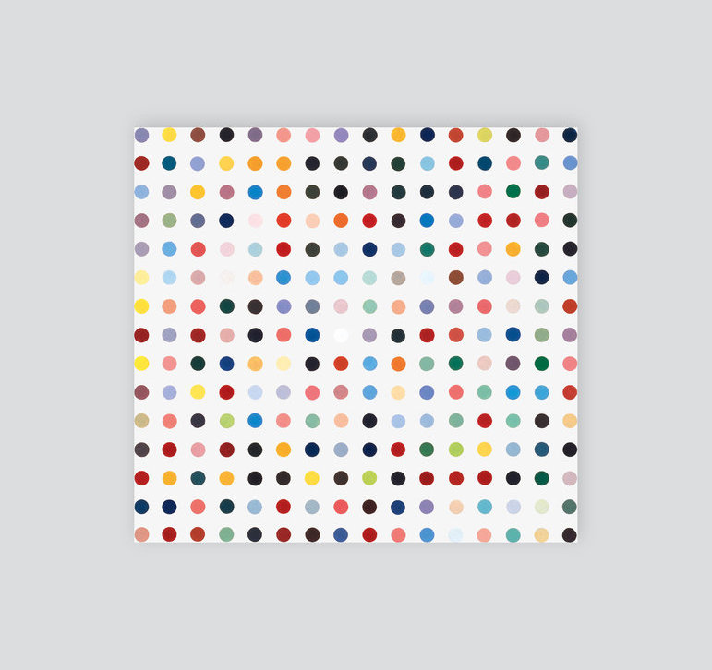

Fig. 4. Damien Hirst. Abalone Acetone Powder from Spot Paintings collection. 1991. <https://damienhirst.com/abalone-acetone-powder>

Another piece that caught my eye was Damien Hirst’s collection called ‘Spot Paintings’ from the 1990s. Hirst sought to structuralize the joy of seeing and experiencing colour by separating each colour and giving its own space within a space. The weird thing about this is that it gives the impression of organization via some type of code, despite the lack of any decipherable logic beneath. What I mean to highlight here, comparing it to Humphries’ “.) green”, is that its regularity and structure says ‘modern’ without having to include any symbols or text. The perfect randomness almost seems akin to that of a written program in something like Processing, and yet it also reminds me of the colour vision tests that circulate on social media a couple times a year with rising and falling trends.

Modernist fantasy and post-modernist fantasy are too large of topics to cover completely in a reasonable space in this section, but it is important to touch on these two terms. Modern fantasy became largely popular in the early twentieth century with the release of J.R.R. Tolkien’s *The Hobbit*. Tolkien’s essay *On Fairy Stories* touches on the fantasy genre and its qualities in great detail, and I would argue it holds a main founding pillar of what fantasy has evolved into in its post-modern phase. This post-modern genre includes works of fantasy that are typically written without using past traditions of the fantasy genre, but it is inherently difficult to put a label on what it is and is not in any exact and precise capacity. The evolution of technology has also greatly influenced fantasy. Having our very own Google machines and portable typewriters in our laptops broadens the places and situations where authors can write or plot ideas. More so is this idea expanded if we consider the blisteringly fast pace of the technological world. The floodgates for creative writing have been lifted in recent years, and the internet has become a preserve not only for visual arts, but for the literate, imaginative kind as well.

**Art in a Pandemic:**Art in a COVID-19 World

Whether people had predicted it or not in December of 2019, the year of 2020 was going to bring about change in all aspects of society. It is here where artists were hit by a tsunami of cancellations and holdings for installations, performances, and collaboration with other artist teams. With the closing of public spaces like exhibition buildings, art museums, and public viewings, artists faced with the quarantines, regulations, and isolations had to find ways to adapt. One such artist is Silvia Lopez Chavez, an interdisciplinary mural artist. She is based in Boston, MA, where she frequently collaborates with urban architects and planners and a multitude of other organizations and groups to install her art. I would like to highlight here the medium of her art, that being wall-paintings and mural paintings. Painting has changed a lot in modern times, and have changed from canvas to any flat surface to the digital sphere. Chavez was interviewed by Irvin Zhang in June of 2020 about the exact changes that artists were facing in the thick of the COVID-19 pandemic in the U.S. She goes on in the interview saying that artists are survivors who must understand their work and role in society and fit that to their needs, and to solve problems with little to no external aid.[15] COVID hit and put everything on a mass pause, even halting the creative processes of artists. This grind to a halt reset many artists to the basis of their creative process, causing them to reassess and reconstruct their art *with* influence, whether its conscious or unconscious, from the presence of COVID-19. This is an interesting observation, as art is a way for the public and for artists to be able to preserve meaning from a situation. Chavez and her public art are of massive import to the people of Boston, as public art is to everyone everywhere. Unlike the art we have seen from the Black Death, this art is far more accessible and, for lack of a better word, public! The existence of the internet acts as a tool of distribution for art like this, especially when people are recommended to stay at home as much as possible. This importance of the *distribution* of art is paramount to our society today, and it marks one of the main differences, save for the natural passage of time and the evolution of society and everything involved within those evolutions and changes, of our world in 2020 against the world of Europe in the 14th and 15th centuries. Art’s capability to be so widespread over the world now allows more people to not only see it, but to relate to it over a digital environment and interact with others who they would not have been able to interact with otherwise. There is also virtual and augmented reality now, which can widen the interaction of the viewers with the piece. An example of this is Regina’s own *Queering the Creek* augmented reality art show, created and implemented by Evie Ruddy and Dan Shier. This particular, time-limited event brought its viewers to Wascana Creek and had eight designated signs or objects that would be ‘tagged’ by a digital footprint along a soundwalk to trigger the appearance of an art piece ranging from spoken word to painting and drawing if someone used the Artivive on the specific object.[16] This concept is particularly interesting to me, and to the overarching theme of the essay, because it involves the placement of art in a public place in a way that is accessible to most everyone along a set, public path that is also outdoors and socially distant!

Visual art is not the only thing the internet has drastically changed. Writing has also felt massive changes and increases in its popularity. As a teaching tool, writing has always been a basic element of the internet. In relation to COVID, with being stuck at home because of the quarantine recommendations, people are reading and writing more in an effort to develop their own hobbies or keep up with the world in a way that they otherwise would not be able to. There are so many sites and web-style courses that are offering tips and aids to those seeking to develop their writing skills as a way to capitalize traffic on their site from the increased amount of time people have had to sit down and learn. As a major historical event, COVID might give us new historical or emotional insights and stories. For readers, it might also affect how they perceive stories in terms of the emotional load that the COVID quarantines retain. As a main vessel for news and journalism, the internet, again, has a pivotal role here. Similar to painting, it provides a common environment for people from all over the world to come together in an effort to maintain outside contact with the world. Online writing groups are a way for people to have writing groups they had before, as some people just need to be ‘around’ others in order to work effectively. Consciously, this stands as an indicator of obvious desire to mingle with others. Unconsciously, these groups are a way for writers to share a sense of togetherness during the pandemic.

**Post-Pandemic Potential:**Where will our art go?

As terrible as the current pandemic, and any pandemic, is or could be, this is a time of “perceptive privilege”. Society today is at such an elevated technological level that we can reread our histories through a screen or via millions of books. History has been recorded in more and more detail as time has gone one, and we are always learning more about it as each minute passes. What’s more is that the documentation of art has also taken off because of its historical implications with each era. Using arts like painting and literature, we allow ourselves to look back on history and the themes common throughout periods of import. We can see this from the examples cited previously with painting, literature, and the Black Death. People change as they come out of a difficult time, and so do the experiences they imprint onto the things they create.

Art today is very wide and far-reaching field, as it can be both a hobby and a job. The number of artistic fields has ballooned; thus, the number of different perceptions and impressions of art has increased with it. Humour is a massive par of the world and how many people deal with trauma, world events, politics, and just with every day life. It allows those with common senses of humour to connect via art and *also* technology, transcending the boundaries of the physical world stalled by COVID-19. Painting and visual art similar to it have become a very public art, more so than when they were in galleries and time-gated. While there will always be the internet, a place for both established and up-and-coming artists to share their work, there is also the public sphere. Our world is filled with blank walls that can act as canvases for painting, and as I mentioned with Evie Ruddy’s *Queering the Creek*, can in turn be canvases in themselves for virtual artworks using our digital devices.

Fantasy literature and the act of writing saw a boom in 2020, despite the isolations and restrictions on in-person work and interactions. This is undoubtedly thanks to the already brimming internet environments of writing blogs and online publication sites. A prime example of these sites, and one I have ventured into as well, is the Wattpad online storytelling platform. Like other blog sites, it functions as a place where people can upload and share their own writing as a way to build a portfolio or, given the chance, build a fanbase around a story. I remember first hearing of the Coronavirus in November of 2019 and dismissing it as just something away from Canada, but then it struck hard in late March 2020 and isolated everyone in the safety of their own homes. During this time since the start of 2020, the number of stories on Wattpad had already grown by 151%, with the number of new writers increasing by a similar metric at 125%.[17] Aron Levitz, the head of Wattpad Studios, says that this increase in traffic represents an “unprecedented time in development”, where the entertainment industry will be able to sit back and view all of these new stories and decide on where it wants to go with some of them post-pandemic. One thing more thing, in which this new age of creative writing may have in common with the painting emergent from the pandemic, will perhaps be the influence of the pandemic itself unto the arts. Writing about the pandemic not only brings relevancy and new emotions into new pieces, but it also brings with it the transcendence of the physical boundary I have mentioned earlier. Every mind is unique and works differently, but seeing or reading others experiencing and *writing* about the same things in a way that is so personal to so many people is a way for everyone to maintain a common part in their experience of post-pandemic art practices. This time might be the golden age of creative development that we all look back on in a few years time, when the pandemic is all but a memory engraved in the brushstrokes of painting and in the words on a page.[18]

Works Cited

Elwell, J. Sage. Crisis of Transcendence a Theology of Digital Art and Culture. Lanham, MD:

Lexington Books, 2010.

Gray, William. Death and Fantasy Essays on Philip Pullman, C.S. Lewis, George MacDonald

and R.L. Stevenson. Newcastle upon Tyne, U.K.: Cambridge Scholars Pub., 2008.

Gsöllpointner, Katharina, Schnell, Ruth, and Schuler, Romana Karla. Digital Synesthesia.

Edition Angewandte. Berlin/Boston: De Gruyter, 2016.

Jost, Jean E. "The Effects of the Black Death: The Plague in Fourteenth-Century Religion,

Literature, and Art." In Death in the Middle Ages and Early Modern Times, 193-238.

Vol. 16. Berlin, Boston: De Gruyter, 2016.

Pinto, Joran. “'There's a Moment of Catharsis Happening': behind Wattpad's Usage Surge.”

Playback, April 9, 2020. <https://playbackonline.ca/2020/04/09/theres-a-moment-of-catharsis-happening-behind-wattpads-usage-surge/>.

Martin, Sean. The Black Death. Harpenden: Oldcastle Books, 2014.

Rexford, Sarah. “How to Write Tactful Fantasy and Science Fiction During COVID-19.” Almost

An Author, May 26, 2020. <https://www.almostanauthor.com/how-to-write-tactful-fantasy-and-science-fiction-during-covid-19/>.

Ruddy, Evie. “Facebook.” Queering the Creek Augmented Reality Art Show, Pride 2020.

Accessed April 1, 2021. <https://www.facebook.com/events/wascana-creek/queering-the-creek-augmented-reality-art-show-pride-2020/649276092674137/>.

Wallace, David. The Cambridge History of Medieval English Literature. Cambridge University

Press, 1999.

Zhang, Irvin. “Here's How Artists Are Creating–and Surviving–during the COVID-19

Pandemic.” News Northeastern Here’s how artists are creating and surviving during the COVID19 pandemic Comments, June 24, 2020. <https://news.northeastern.edu/2020/06/24/heres-how-three-artists-are-creating-art-and-surviving-during-the-covid-19-pandemic/>.

1. S. Martin. *The Black Death.* (Harpenden, Oldcastle Books. 2016.) P. 11
2. S. Martin. *The Black Death.* (Harpenden, Oldcastle Books. 2016.) P. 23
3. S. Martin. *The Black Death.* (Harpenden, Oldcastle Books. 2016.) P. 117
4. J. Jost. *The Effects of the Black Death: The Plague in Fourteenth-Century Religion, Literature, and Art.* (Berlin, Boston. De Grutyer. 2016.) P. 232
5. J. Jost. *The Effects of the Black Death: The Plague in Fourteenth-Century Religion, Literature, and Art.* (Berlin, Boston. De Grutyer. 2016.) P. 220
6. J. Jost. *The Effects of the Black Death: The Plague in Fourteenth-Century Religion, Literature, and Art.* (Berlin, Boston. De Grutyer. 2016.) P. 199
7. J. Jost. *The Effects of the Black Death: The Plague in Fourteenth-Century Religion, Literature, and Art.* (Berlin, Boston. De Grutyer. 2016.) P. 203
8. D. Wallace. *The Cambridge History of Medieval English Literature.* (Cambridge University Press. 1999.) P.146
9. D. Wallace. *The Cambridge History of Medieval English Literature.* (Cambridge University Press. 1999.) P.146
10. J. Jost. *The Effects of the Black Death: The Plague in Fourteenth-Century Religion, Literature, and Art.* (Berlin, Boston. De Grutyer. 2016.) P. 190
11. W. Gray. *Death and Fantasy Essays on Philip Pullman, C.S. Lewis, George MacDonald and R.L. Stevenson.* (Newcastle, UK. Cambridge Scholars Pub. 2008.) P. 56
12. J. Elwell. *Crisis of Transcendence a Theology of Digital Art and Culture.* (Lanham, MD: Lexington Books, 2010.) P. 8
13. J. Elwell. *Crisis of Transcendence a Theology of Digital Art and Culture.* (Lanham, MD: Lexington Books, 2010.) P. 17
14. J. Elwell. *Crisis of Transcendence a Theology of Digital Art and Culture.* (Lanham, MD: Lexington Books, 2010.) P. 15
15. I, Zhang. “Here's How Artists Are Creating–and Surviving–during the COVID-19 Pandemic.” *News.northeastern.edu.* <https://news.northeastern.edu/2020/06/24/heres-how-three-artists-are-creating-art-and-surviving-during-the-covid-19-pandemic/>
16. E. Ruddy, “Queering the Creek”, 2020. <https://www.facebook.com/events/wascana-creek/queering-the-creek-augmented-reality-art-show-pride-2020/649276092674137/>
17. J. Pinto, “'There's a Moment of Catharsis Happening': behind Wattpad's Usage Surge.” [*playbackonline.ca*](https://playbackonline.ca)*,* 2020. <https://playbackonline.ca/2020/04/09/theres-a-moment-of-catharsis-happening-behind-wattpads-usage-surge/>
18. J. Pinto, “'There's a Moment of Catharsis Happening': behind Wattpad's Usage Surge.” [*playbackonline.ca*](https://playbackonline.ca)*,* 2020. <https://playbackonline.ca/2020/04/09/theres-a-moment-of-catharsis-happening-behind-wattpads-usage-surge/>